Video object detection using Yolov8 CLI | object

detection in video using Google Colab

ABSTRACT

▶ Video object detection or object detection from video is the

most common use case for object detection. We will use a

pretrained YOLOv8m.pt model from Ultralytics and try to find

the objects in the video frame by frame. We will also compress

the output video using ffmpeg and then play the video in the

Video

INTRODUCTION:

▶ YOLOv8, a high-speed, high-accuracy object detection image

segmentation model. YOLOv8 is the latest version of YOLO

by Ultralytics. As a cutting-edge, state-of-the-art (SOTA)

model, YOLOv8 builds on the success of previous versions,

introducing new features and improvements for enhanced

performance, flexibility, and efficiency. YOLOv8 supports a full

range of vision AI tasks, including detection, segmentation,

pose estimation, tracking, and classification. This versatility

allows users to leverage YOLOv8’s capabilities across diverse

applications and domains.

▶ Implementation YOLO V8 on a video for object detection on

Google colab

PROCESS TO START

▶ Take GPU for quick process if not it will take lot of time.

▶ Install ultralytics with pip and get up and running in minutes

Ultralytics provides various installation methods including pip,

conda, and Docker. Install YOLOv8 via the ultralytics pip

package for the latest stable release or by cloning the

Ultralytics GitHub repository for the most up-to-date version.

Docker can be used to execute the package in an isolated

container, avoiding local installation.

▶ !pip install ultralytics -q as flag basically it will download

ultralytics for us which helps us to instantiate our YOLO Class.▶ Predict new images and videos with YOLOv8 .

▶ command line interface (!)

!yolo detect predict model=yolov8m.pt source

here we use YOLO V8 medium as our pretrained model, for

source add the video file path.

▶ It will run and make folder as run , open the run folder it will

consists of detect, open detect folder it has predict folder

consists of our video file.

▶ This video file will not work because it is not compressed till

now so to work we have to compress the video file.

▶ !ffmpeg -i " " -vcodec libX264 " "

▶ !ffmpeg -i " " - here give the video file path to be compressed.

▶ -vcodec libx264 " " - give final name of the video file name.

▶ Enter the code and do shift and enter.

Final video will appear download it .

▶ Run it. When we play the video file we can see the object

detections in it as cars, trains , person and trucks etc..

RESULT

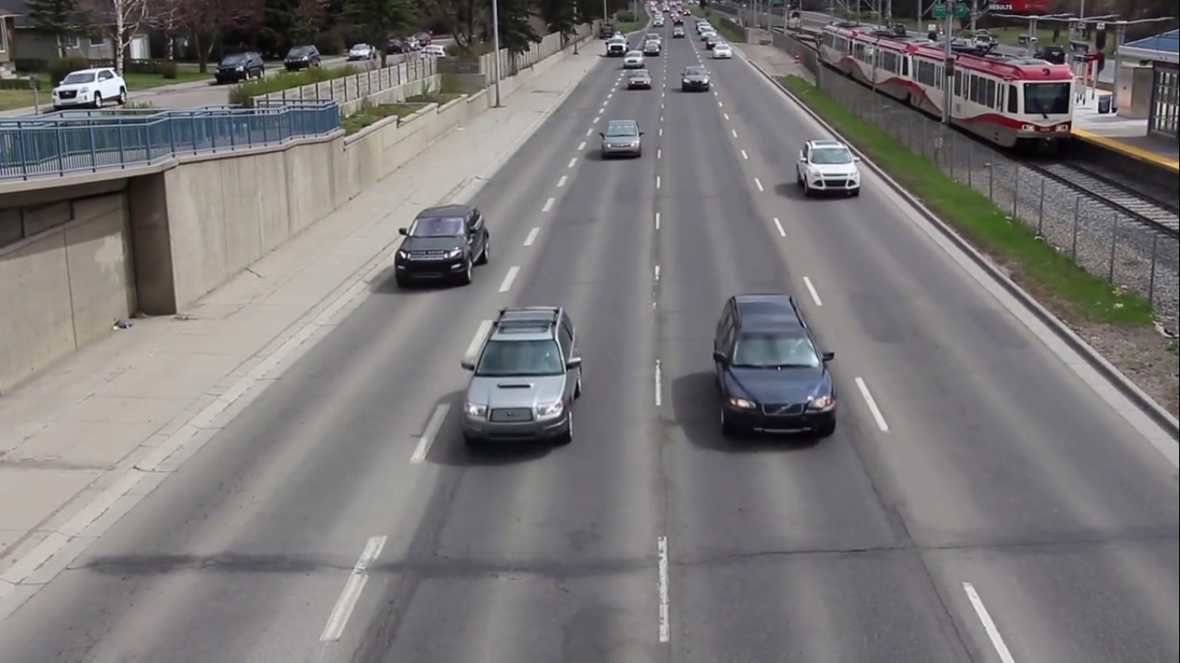

Figure 1: Input video file

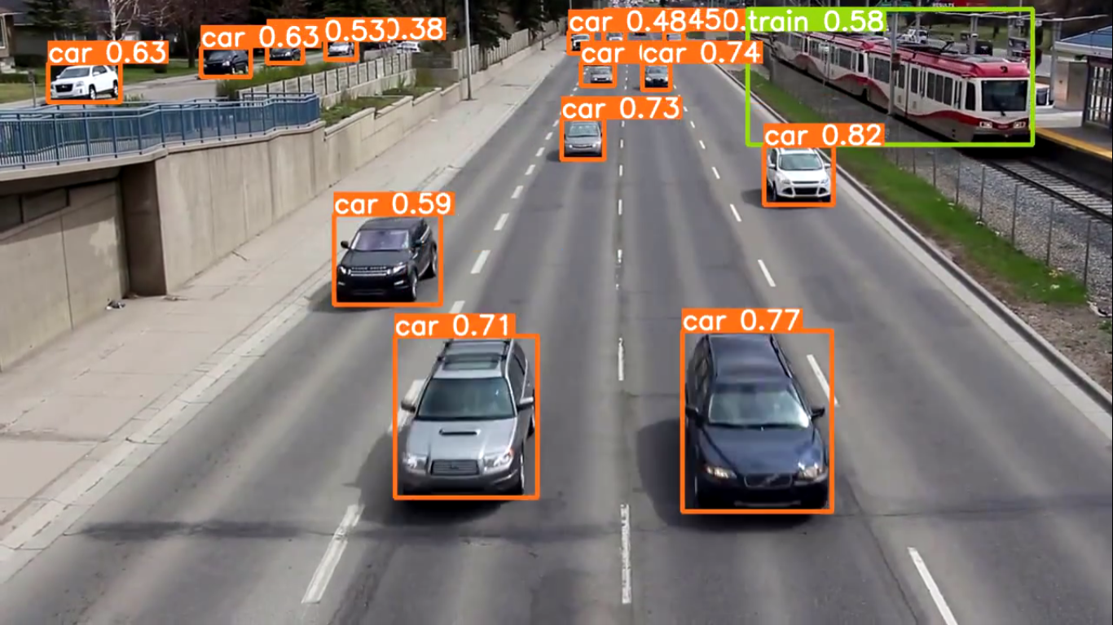

Figure 2: Output video file

CONCLUSION:

▶ Real-time performance: YOLO (You Only Look Once) models

are known for their real-time object detection capabilities,

making them suitable for video object detection tasks where

low latency is crucial.

▶ Accuracy: YOLOv4 provided state-of-the-art accuracy in

object detection, outperforming its predecessors. If YOLOv8 or

newer versions exist, it’s likely they would have further

improved accuracy through architectural advancements or

additional training data.

▶ Object detection on video streams: YOLO models can process

video streams frame by frame, allowing for continuous object

detection in videos.▶ Object tracking: For video object detection, merely processing

frames independently might lead to inconsistencies in the

detected objects between consecutive frames. Implementing

object tracking techniques along with YOLO can improve the

continuity and consistency of detected objects across frames.

▶ Hardware requirements: YOLOv4 is computationally

demanding, requiring powerful GPUs to achieve real-time

performance. If YOLOv8 has been developed, it may have

further increased hardware requirements or might have

optimized for more efficient performance.

▶ Pre-trained models: If YOLOv8 or newer versions have been

released, there might be pre-trained models available on

popular deep learning frameworks, making it easier to

implement video object detection.

FUTURE SCOPE:

▶ YOLOv8, an evolution of the YOLO (You Only Look Once)

architecture, boasts significant advancements in object

detection

▶ It offers enhanced accuracy and faster inference times due to a

deeper and more optimized network design.

▶ YOLOv8 utilizes a combination of anchor boxes and feature

pyramid networks for improved localization and recognition of

objects across different scales.

▶ With its efficient darknet-53 backbone, it achieves

state-of-the-art performance on various object detection

benchmarks.

▶ YOLOv8 is a powerful and popular choice for real-time video

object detection tasks, making it a top option for applications

like surveillance, autonomous vehicles, and more.